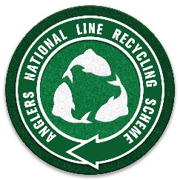
ANGLERS NATIONAL LINE RECYCLING SCHEME

TACKLE SHOP / FISHERY REGISTRATION

Many thanks for your interest in the ANLRS. To take part in the scheme please complete the details below and email it through to us.

All we ask is that you source a recycling bin and ANLRS will send you the bin and window stickers free of charge.

Address | Name
 | No
 | Street
 | Town
 | County
 | Post Code
Contact | Name
 | Phone
 | Email

Would you like to offer any incentive to customers bringing line into your shop? |  |  |  |  |  |  |  | Yes | No
(eg discount on new line / free respooling. Please detail below)

Would you consider distributing ANLRS postal envelopes to anglers buying |  |  |  |  |  |  |  | Yes | No
new line from you?

Contact us via anglersnlrs@gmail.com

Currently collected line can be posted to
Tools n Tackle, 11 Bridge Street, Newhaven. Sussex BN9 9PH

A national collection network is being investigated currently and we will keep you updated.
We are building the ANLRS website at present and you will be included as a participating shop / fishery and supporter on the website.

Line recycling-'something the whole of Angling can agree on'

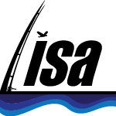 Founded by LISA in association with the GGGI

